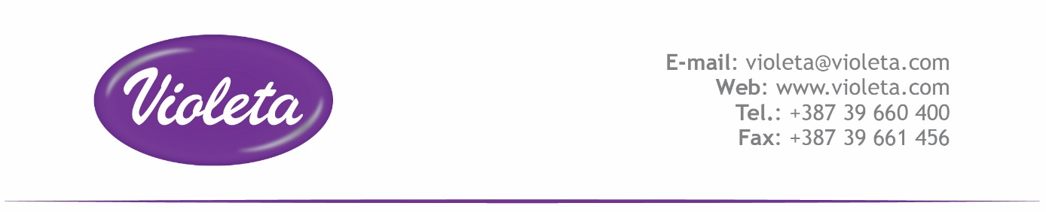 PRODUKTNAME: ***Clever Geschirrspülmittel Konzentrat Balsam Duft, 500 ml***

|  |
| --- |
| **Sastojci (List of ingredients)** |
| Natriumlaurethsulfat |
| Cocamidopropylbetain |
| Natriumchlorid |
| Natriumhydroxid |
| Parfüm |
| Benzisothiazolinon |
| Natriumpyrithion |
| Glycerin |
| Wasser |

Correlation between European Pharmacopoeia INCI names and CAS numbers: http://ec.europa.eu/consumers/cosmetics/