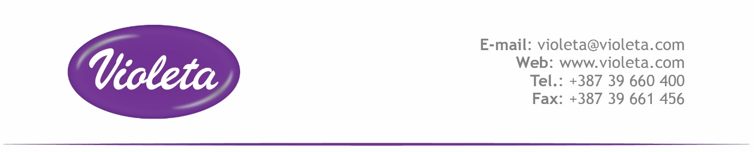 IME PROIZVODA (PRODUCT NAME): **CLEVER HAND DISHWASHING DETERGENTS ORANGE**

|  |
| --- |
| **Sastojci (List of ingredients)** |
| SODIUM LAURETH SULFATE |
| Cocamidopropyl Betaine |
| SODIUM CHLORIDE |
| SODIUM HYDROXIDE |
| PERFUME |
| BENZISOTHIAZOLINONE |
| SODIUM PYRITHIONE |
| COLORANT |
| WATER |

Correlation between European Pharmacopoeia INCI names and CAS numbers: http://ec.europa.eu/consumers/cosmetics/