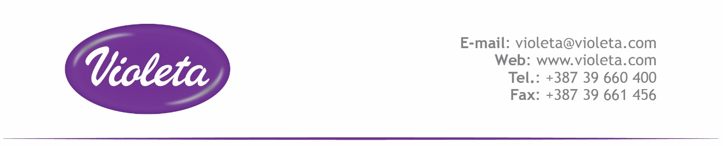 IME PROIZVODA (PRODUCT NAME): **VIOLETA INTENSE COLOR**

|  |
| --- |
| **Sastojci (List of ingredients)** |
| AQUA |
| SODIUM LAURETH SULFATE |
| LINEAR ALKYL BENZENE SULFONIC ACID |
| LAURETH-7 |
| TOPPED PALM KERNEL FATTY ACID |
| GLYCEROL |
| TRISODIUM CITRATE DIHYDRATE |
| PARFUM |
| SODIUM CHLORIDE |
| SODIUM HYDROXYDE |
| PHOSPHONATES (DTPMP-Na) |
| COPOLYMER BASED ON METHACRYLIC ACID AND ACRYLIC ACID ESTERS |
| VINYLPYRROLIDONE/VINYLIMIDAZOLE COPOLYMER, MODIFIED |
| BENZISOTHIAZOLINONE |
| METHYLCHLOROISOTHIAZOLINONE |
| METHYLISOTHIAZOLINONE |
| ENZYMES |
| CALCIUM CHLORIDE |
| STYRENE/ACRYLATES COPOLYMER |

Correlation between European Pharmacopoeia INCI names and CAS numbers: http://ec.europa.eu/consumers/cosmetics/